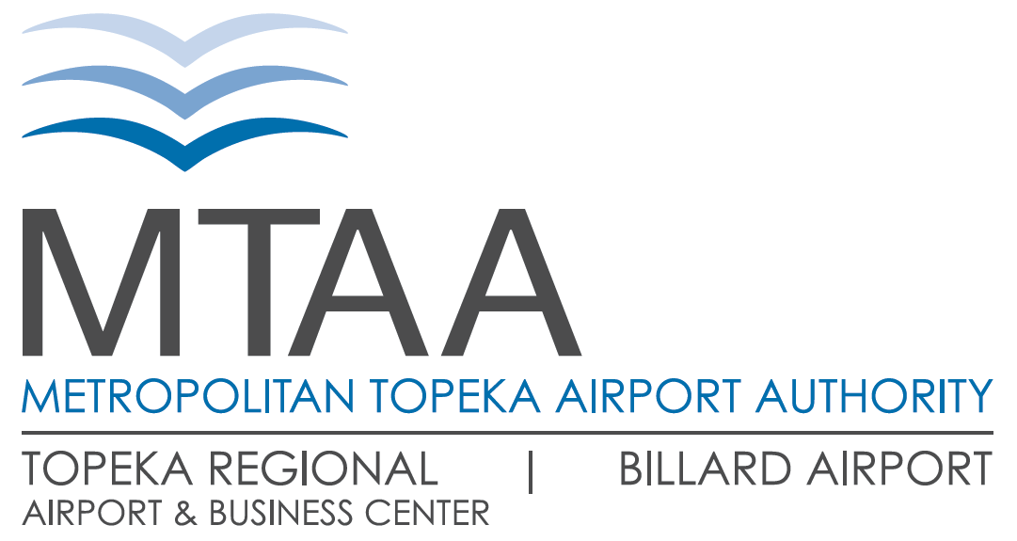**Topeka Regional Airport & Business Center, Bldg. 620**

**6510 SE Forbes Ave., Ste. 1, Topeka, KS 66619-1446**

**Phone :: 785.862.2362 | Fax :: 785.862.1830**

**mtaa-topeka.org**

**Class Title:** Electrician

**Position Summary:**

Under general supervision, this position performs electrical building systems and equipment maintenance/repair, as well as building modifications and new construction projects, addresses and oversees projects assigned by the Airport President and Maintenance Department Management. May perform other duties as assigned.

**Essential Job Functions:**

* Maintenance, repair and troubleshooting of electrical distribution systems, circuits, load centers, control panels and motors.
* Electrical repairs to MTAA owned or leased buildings/property to include all airfield electrical
* Maintain lighting systems - Change lamps, replace ballasts, repair or replace fixtures as assigned.
* Maintain emergency power systems - Provide testing and maintenance to emergency power systems including UPS and generator sets and related systems.
* General maintenance, snow removal, work station changes and clerical responsibilities.

**Required Qualifications:**

* High School Graduate
* Licensed Journeyman Electrician in Topeka, KS
* Thorough knowledge of the National Electric Code. (Including building, electrical and life safety code requirements.)
* Three (3) years’ experience as a service electrician AND two (2) or more years’ experience in electrical construction.

**Desirable Qualifications:**

* Working knowledge of building construction.
* Considerable knowledge in HVAC and Airfield Lighting.
* Ability to read and understand blueprints and electrical schematics.
* Ability to identify potential problems and take steps to correct them.
* Working knowledge of location, identity, and interior layout of all facilities owned/leased by MTAA.

The statements contained herein reflect general details as necessary to describe the principal functions of this job, the level of knowledge and skill typically required, and the scope of responsibility, but should not be considered an all inclusive listing of work requirements. Individuals may perform other duties as assigned, including work in other functional areas to cover absences or relief, to equalize peak work periods, or otherwise balance the workload. Requires standing, walking and heavy lifting. Handle tools or controls. Reasonable accommodations may be made to enable individuals with disabilities to perform essential functions. Exposure to sounds and noise levels that may be distracting or uncomfortable. Working in very hot or very cold temperatures. Working in cramped work spaces and getting into awkward positions. Requires working with others in a group or team, responsibility for the health and safety of others, wearing common protective or safety equipment, job tasks are performed in close physical proximity to other people. **Individuals must be able to pass a Triple I (III) and/or CHRC Fingerprint background check**.

Signature Date